**DESIGN AND CONSTRUCTION OF AUTOMATIC EMERGENCY POWER SUPPLY USING BACKUP BATTERY**

**BY**

**MUHAMMED Usman**

**(ET/EE/HND/21/011)**

**A PROJECT REPORT SUBMITTED IN PARTIAL FULFILMENT**

**OF THE REQUEMENT FOR THE AWARD OF HIGHER NATIONAL DIPLOMA IN**

**ELECTRICAL AND ELECTRONIC ENGINEERING**

**DEPERTMENT OF ELECTRICAL AND ELECTRONIC ENGINEERING**

**TECHNOLOGY, FEDERAL POLYTECHNIC MUBI.**

**SEPTEMBER, 2023**

# DEDICATION

I dedicate this work to Almighty Allah and to my beloved family and friends for their endless love, prayers and support.

# DECLARATION

I hereby declare that the project work entitled “Design and Construction of Automatic Emergency Power Supply Using Backup Battery” was written by me **MUHAMMED Usman** It is my record of work; The work has not been presented or submitted elsewhere for consideration of degree/diploma/certificate award. All references made to published literatures have been duly acknowledged.

Signature………………………. Date……………………

**MUHAMMED Usman**

(ET/EE/HND/21/011)

# CERTIFICATION

This is to certify that this project work “Design and Construction of Automatic Emergency Power Supply Using Backup Battery” presented by MUHAMMED Usman has been written in accordance with regulations governing the preparation and presentation of projects in the Federal polytechnic Mubi and meets the requirements for the award of Higher National Diploma in Electrical and Electronics Engineering Technology.

Signature…………………………….. Date………………………………..

**MUHAMMED Usman**

(ET/EE/HND/21/011)

Signature…………………………… Date………………………………..

**Chief Ijafiya J. Medugu**

(Project Supervisor)

# APPROVAL

This project report entitled “Design and Construction of Automatic Emergency Power Supply Using Backup Battery” presented by **MUHAMMED Usman** was submitted to the Department of Electrical and Electronics Engineering Technology and has been accepted as partial fulfilment of the requirement for the award of Higher National Diploma in Electrical and Electronics Engineering Technology. Federal polytechnic, Mubi.

Signature…………………………… Date……………………………

**Chief Ijafiya J. Medugu**

(Project Supervisor)

Signature…………………………… Date……………………………

**Engr. Victor O. N.**

(Head of Department)

Signature…………………………… Date……………………………

E**ngr. Muhammad Aliyu Gadam Ph.D**

(External Supervisor)

# ACKNOWLEGMENT

First and foremost, I acknowledge Almighty Allah for the kn0owledge and protection given to me throughout my program.

Secondly, I will like to acknowledge the help and support of my supervisor, Chief Ijafiya I. Medugu, I will also like to acknowledge my beloved parent, brothers and sisters and all my relatives.

I also want to appreciate my HOD of electrical engineering, Engr Victor O. Nkeleme and all my lecturers for the knowledge they have impacted in me.

I will like to acknowledge my beloved sister, second mother Fadi Muhammad for her guidance and support throughout my life.

Finally, I wish to appreciate the effort of the project coordinators Engr Kaigma A. Mu’awiya and the entire staff of electrical and electronic engineering, my colleague and friend, who in one way or the other had contributed to the success of this work.

Thank you all may Allah bless you all wa-sallam.

# ABSTRACT

*Power failure does not promote power sector and retard growth of industries therefore the induction of automatic emergency power supply using backup batter inverting circuit will help in promoting the power sector. There are some processes that cannot be distracted, e.g. surgery in hospital, transfer of money from bank to bank and airports etc. constant power supply is necessary. Automatic emergency power supply will stop the work off manual operator and is more reliable than the manual change over switch and the backup battery will reduce the expenses of buying fuel for generator used in subsequent projects that I have seen. The key component for these components is power banks, relay e.d 4047, MOSFET, transistor and public power supply.*

# TABLE OF CONTENT

CONTENT Page

DEDICATION ii

DECLARATION iii

CERTIFICATION iv

APPROVAL v

ACKNOWLEGMENT vi

ABSTRACT vii

TABLE OF CONTENT viii

LIST OF TABLES x

LIST OF FIGUERS xi

CHAPTER ONE 1

INTRODUCTION 1

1.1 Background of the Study 1

1.2 Statement of The Problem 3

1.3 Aim and Objectives 4

1.4 Significance of the Study 4

1.5 Scope of the Study 5

1.6 Limitation 5

CHAPTER TWO 6

LITERATURE REVIEW 6

2.1 Related Work 6

2.2 Theoretical Review 10

2.21 Security Door System Using Human Tracking Method with Laser Range Finders 10

2.22 Raspberry-pi based home security system 11

2.23 Cloud Based home automation system 12

2.24 Home security system using Siri enabled mobile device 12

CHAPTER THREE 14

SYSTEM DESIGN AND ANALYSIS 14

3.1 Block Diagram of Sound Detector 14

3.2 System Sections Description 14

3.2.1 The Power Supply Design 14

3.2.2 The PIR Sensor Design 15

3.2.3 Output Transducer (Piezo Buzzer) 16

3.2.4 The Output Switch 17

3.7 Principle of Operation 19

CHAPTER FOUR 20

CONSTRUCTION, TESTING AND RESULT 20

4.1 Component List 20

4.2 Construction 21

4.2.1 Component Circuit Layout 21

4.2.2 Soldering 21

4.3 Prototype Casing And/Packaging 23

4.4 Prototype Testing 24

4.4.1 Sectional Circuit Testing 24

4.4.2 Complete Prototype Testing 24

4.5 Results 25

4.6 Discussion 26

CHAPTER FIVE 27

SUMMARY, CONCLUSION AND RECOMMENDATIONS 27

5.1 Summary 27

5.2 Conclusion 27

5.3 Recommendation 28

REFERENCES 29

# LIST OF TABLES

**TABLE Page**

Table: 4.1 List of components………………………………………………….……….. 20

Table: 4.2 Static Test………………………………….……………………….……....... 25

Table 4.3: Prototype Test Result………….…………………………………...………… 25

# LIST OF FIGUERS

**FIGURE**  **Page**

Figure 2.1: Security door system…………………………………………………………... 10

Figure 2.2: Raspberry-pi based home security system……………………………….……. 11

Figure 2.3: Home security system using Siri enabled mobile device……………………… 12

Figure 3.1: The Block diagram of the ultrasonic based door security alarm………………. 14

Figure 3.2: The PIR Sensor……………………………………………………………........ 16

Figure 3.3: The buzzer……………………………………………………………………... 17

Figure 3.4: The switch circuit…………………………………………………………........ 17

Figure 3.5: Complete Circuit Diagram…………………………………………………….. 19

Figure 4.1 component Layout…………………………………………………………….... 21

Figure 4.3: The strip board laid circuit…………………………………………………….. 23

Figure 4.4: Casing Design of the US proximity detector alarm……………………….…... 24

# CHAPTER ONE

# INTRODUCTION

Constant power is a critical requirement for many situations encountered in today’s modern world, however constant power is not a guarantee as power systems are prone to failures as such it has become necessary to device means of maintaining constant power via special power supplies called automatic emergency power supplies. This chapter serves as an introduction to the study and practical realization of uninterruptible power supplies. The chapter contain the background of the study, statement of the problem or problem statement, aim and objectives of the study, significance of the study, scope of the study and the methodology adopted in the achieving the objectives of the project.

## 1.1 Background of the Study

It is evident that every electrical and electronic equipment needs to be energized by means of a power supply. In most cases the power is required to be delivered to the load circuit at steady or fixed voltage. However, stability of such main power supply is a source of concern because insufficiency and accompanying power outage have always posed major setbacks to individuals and organizations which depend on sensitive electronic equipment that require constant power supply. Such interruption of mains supply has caused serious inconveniences especially in highly sensitive devices such as computers, medical equipment and industrial research laboratories where interruption of power could spell danger (Sufi, 2020). Power outage is an unavoidable phenomenon and the need for reliable back up or emergency power supply system cannot be over emphasized, which is what has led to the design of this project. In order to protect such sensitive electronic systems from inactivity resulting from power failure, it is necessary to provide an alternative power source, which will automatically power the system in the event of mains failure. Though the likes of the unit are in the market, they have an operation period in the range of 30 minutes to 1 hour and are mostly imported, which is not exactly suitable for our present power supply environment (Musa and Chukwurah, 2020). The objective of this article is to present a UPS that has been designed and built to overcome some of these setbacks by having an operation period or autonomy of up to 2 hours. Some systems that perform similar functions to the UPS exist. One of such is the Storage Battery-Emergency DC System. This system is used primarily for emergency lighting, fire alarms and emergency communications systems. It consists of an automatic charger, a battery and an emergency dc bus. It is statutorily required that the system be capable of maintaining the total load for a period of one and half hours minimum without the load voltage falling below 87.5% of normal (Kusko, 2019).

Another such system is the Engine Generator System. This system typically consists of the petrol or diesel engine or a gas or steam turbine and an ac synchronous generator control. It is always incorporated with a transfer switch - manual or automatic. This switch is normally set to transfer the load to the set 10 seconds after the engine is started (Kusko, 2019). Whenever there is power outage, the engine is started either manually or automatically. As soon as the generator output reaches nominal voltage and frequency, the transfer switch operates to connect the load to the set. When the main automatically to return the load to the utility main supply, (Barnett, 2020).

## 1.2 Statement of the Problem

The frequent fluctuations of supply voltage in the country nowadays have become a very serious problem to industrial and home appliances. This fluctuation of voltage sometimes causes very low voltage (under voltage) or very high voltage (over voltage) which eventually damages electrical appliances if not protected. (Adewale and Ogunleye, 2019) Several devices have been used to protect both industrial and domestic equipment and appliances against sudden voltage changes. These devices include voltage stabilizers with built in surge suppression circuits, the uninterruptible power supply (AEPS) system filters.

## 1.2    Aim and Objectives of the Project

The main purpose of this project is to design a system that will serve as an alternative means of power supply in homes, offices and other places in case of main supply failure. specific objectives of the project are to:

1. To design a battery backup and automatic transfer switch system which will offer protection against equipment damage and data loss.
2. To construct a battery backup system and an automatic transfer switch.
3. Test and Analyze
4. Ensure that the Project produce an inverter and step-up transformer that would be able to transform few D.C voltage of about 12 voltages to up to 220 volt A.C 50Hz obtainable from the national power supply.
5. Electronic appliances designed and constructed for use in Nigeria are protected from voltage outages when powered from the automatic emergency power supply using backup battery

## 1.3 Significance of the Study

The fluctuation of power supply in a developing country like Nigeria could be quite fatal due to the damage to sensitive appliances such as television sets, DVD players, radio sets, computers etc. Therefore, this project work when installed in the house or office helps in mitigating this problem to a greater extent, thereby making this project highly significant. It will also serve as a reference material for the construction of over voltage protecting device in the future.

## 1.4 Scope of the Project

This project is on the design and construction of 1KVA automatic emergency power supply system with an in-built battery supply. In the first place, the 12 VDC battery is not part of the system to be designed implemented. The scope of the project includes designing and deriving the component values of all the circuits involved for the implementation of this project. These components are sourced and fixed in the vero board according to the determined circuitry, wired and tested through. The circuitry is completed by the design of transformer laminations and coils or windings, packaging and clamping of these laminations to air tight condition and testing through to ensure the specified rating of 1KVA which will supply a real power of 1KVA x 0. 8..

# CHAPTER TWO

# LITERATURE REVIEW

The 1KVA automatic emergency power supply system with an in-built battery supply basically consists of several subsystems interconnected to perform a single purpose. The sub-systems are charger, battery, inverter and several switches. This chapter gives an overview of the project by providing background information on uninterruptible power supplies and work by other authors on same or similar topic. Numerous works and researches have been done in the area of inverter and AEPS design and implementation. Various electronic components are being used to achieve the process of inversion and un-interruption of power supply in electrical power system. Factors such as power handling capacity and switching speed are being researched into on daily basis and these normally dictate the type of switching components to use in a particular circuit.

The following are some reviewed past principles and work carried out by different people on same or similar work to this:

## 2.1 Review of Related Work

In the work of Omitola et al, (2021) “Design and construction of 1kW power inverter,” the system voltage is 12V DC and the output is 220V AC at 50Hz. The basic principle of its operation is a simple conversion of 12V DC from a battery using integrated circuits and semiconductors at a frequency of 50Hz, to a 220V AC across the windings of a transformer. Also, Kabir Usman submitted a project titled “Design and Construction of 3kVA Power Inverter (24V DC – 230V AC)” which works on the principle of UPS. He made use of appropriate oscillator circuit, transformers, switching, and control circuits. Incorporated into these systems are devices such as transistors, MOSFETs, diodes, resistors and batteries which work hand in hand to obtain the overall desired operation of an inverter . Considering the effort of Babarinde et al in “Design and Construction of 1KVA Inverter” The overall operation of the system comprises inter connections of many sub-circuits to give optimum performances. The sub circuits include the oscillator circuit, PWM circuit, driver circuit, low battery/overload shutdown circuit, charging control/soft charging circuit, surge protection circuit, changeover/power supply circuit, and the output circuit (MOSFET and transformer section). None of these works incorporates into their inverter system the section that is capable of making use of more than one source of AC input e.g. the use of generator and public utility supply as AC inputs in an interchangeable manner.

Jonathan (2007), designed and constructed automatic power change over Switch,the operation of the power unit was well organized and coordinated for efficient performance. The power circuit is not active when there is A Cmains supply. When the AC power supply fails, the switching mechanism of the generator is automatically activated. There is a delay in the loading, of the generator so as to attained stability for a while, after the said delay the generator is loaded. The power supply from the generator is interchanged the moment the AC mains are restored, immediately after this the generator is automatically switched.

Saheer (2014), design and implemented a solar power system with 120w power that will take care of lighting system by using lower voltage consuming lamps.

Mohammed (2015), design constructed and installed a 1000w inverter using solar power system. The have succeeded in providing alternative source of power supply by means of solar energy system

Natick (1988), designed and constructed emergency power supply, during normal conditions the uninterruptible power supply is operated by the power in the input line derived from an AC power line and supplies operating power to the equipment on the output line. The charger draws power from the input line and maintain a full charge on the battery. Detecting the presence of line voltage on the input line is the AC voltage sensor, that responds to that condition by maintaining the switch open there by disconnect the light from the battery. Under abnormal condition when AC line power is 'on' the input line has been interrupted, the power to the equipment is derive from the battery. The battery voltage is converted by the uninterruptable power supply to the voltage suitable for the operation of the equipment. Detecting an absence of the AC line voltage on the Input line, the AC voltage sensor automatically activate the switch into a close condition connecting the battery to the light. The bulb provides immediate illumination for personnel operating the equipment. Because the light is connected directly to the battery by the switch no lighting power is consumed in the power supply.

Aleksey *et al.* (2020) proposed method to design a standalone hybrid UPS system with solar and diesel generators. The paper dealt with designing and analysis of complexities in the hybrid system for electric supply in Russia. According to the paper that he proposed, Construction of decentralized power supply system needs independent sources of electric power using fossil fuels, most common and versatile of which are diesel power plants (DG). Analysis of wind maps and solar opportunities in Russia shows that an alternative to the use of DG is the use of renewable electrical energy, by including own photoelectric and wind power station (PhG and WG) into the scheme of power supply for electric consumer’s scheme as primary or auxiliary power source. However, in order to increase DG fuel efficiency within complex, batteries and super-capacitors should be included.

Manzar *et al.* (2020) Presented model for a microgrid with solar, wind, inverter etc. according to the paper the main components of Microgrid are mini-hydro, solar cell, wind energy, fuel cell and energy storage system. These are integrated for electricity generation, energy storage, and a load that normally operates connected to a main grid (macro grid). Microgrid can operate in two modes: one is grid-connected and the other is stand-alone mode. The main benefit of Microgrid is that it can operate in standalone mode or main grid disconnection mode. The Microgrid can then function autonomously. Generation and loads in a Microgrid are usually interconnected at low voltage. But one issue related to Microgrid is that operator should be very vigilant because numbers of power system are connected to Microgrid. In the past, there was single entity to control. In Microgrid generation resources can include such as fuel cells, wind, solar, or other energy sources as shown in Figure 1. These multiple different electric power supply generation resources have ability to isolate the Microgrid from a large network and will provide highly reliable electric power.

Hans-Peter *et al.* (2020), proposed an invention which delas with the continuous supply of n loads with n+1 inverters. In the context of these existing modular inverter architectures the critical load is always connected to the energy source via the static switch, in off line as Well as in on line mode. Therefore, if the static switch fails the power supply for the critical load is interrupted. This susceptibility to single point failures of the static switch constitutes a major drawback or the known architecture. Such single point failures may be caused by a number of reasons such as microcontroller resets, defects of the quartz clock circuit for the microcontroller or the microcontroller itself, defects in the circuit, which may short circuit the auxiliary supply, a defect of the auxiliary supply or many other reasons. But on using n+1 inverters the single point faliures no longer remain a critical event.

## 2.3 Theoretical Review

### 2.3.1 Automatic Emergency Power supply

An automatic emergency power supply or uninterruptible power source (AEPS) is an electrical apparatus that provides emergency power to a load when the input power source or [mains power](https://en.wikipedia.org/wiki/Mains_electricity) fails( solter, 2019). A UPS differs from an auxiliary or [emergency power system](https://en.wikipedia.org/wiki/Emergency_power_system) or [standby generator](https://en.wikipedia.org/wiki/Standby_generator) in that it will provide near-instantaneous protection from input power interruptions, by supplying energy stored in batteries, [super capacitors](https://en.wikipedia.org/wiki/Supercapacitor), or [flywheels](https://en.wikipedia.org/wiki/Flywheel). The on-battery run-time of most uninterruptible power sources is relatively short (only a few minutes) but sufficient to start a standby power source or properly shut down the protected equipment. It is a type of [continual power system](https://en.wikipedia.org/wiki/Continual_power_system) (Solter, 2019).

A emergency power supply is typically used to protect hardware such as [computers](https://en.wikipedia.org/wiki/Computer), [data centers](https://en.wikipedia.org/wiki/Data_center), [telecommunication](https://en.wikipedia.org/wiki/Telecommunication) equipment or other electrical equipment where an unexpected power disruption could cause injuries, fatalities, serious business disruption or data loss. AEPS units range in size from ones designed to protect a single computer without a video monitor (around 200 [volt-ampere](https://en.wikipedia.org/wiki/Volt-ampere) rating) to large units powering entire data centers or buildings. The world's largest UPS, the 46-megawatt Battery Energy Storage System (BESS), in [Fairbanks, Alaska](https://en.wikipedia.org/wiki/Fairbanks,_Alaska), powers the entire city and nearby rural communities during outages.(Ton, 2019) (Sufi, 2020)

The primary role of any AEPS is to provide short-term power when the input power source fails. However, most AEPS units are also capable in varying degrees of correcting common utility power problems:

1. [Voltage spike](https://en.wikipedia.org/wiki/Voltage_spike) or sustained [overvoltage](https://en.wikipedia.org/wiki/Overvoltage)
2. Momentary or sustained [reduction in input voltage](https://en.wikipedia.org/wiki/Brownout_(electricity))
3. [Voltage sag](https://en.wikipedia.org/wiki/Voltage_sag)
4. Noise, defined as a [high frequency transient](https://en.wikipedia.org/wiki/Line_noise) or [oscillation](https://en.wikipedia.org/wiki/Transient_(oscillation)), usually injected into the line by nearby equipment
5. Instability of the [mains frequency](https://en.wikipedia.org/wiki/Mains_frequency)
6. [Harmonic distortion](https://en.wikipedia.org/wiki/Harmonic_distortion), defined as a departure from the ideal [sinusoidal](https://en.wikipedia.org/wiki/Sinusoidal) [waveform](https://en.wikipedia.org/wiki/Waveform) expected on the line

Some manufacturers of UPS units categorize their products in accordance with the number of power-related problems they address (Ton, 2019).

A AEPS unit may also introduce problems with [electric power quality](https://en.wikipedia.org/wiki/Electric_power_quality). To prevent this, a AEPS should be selected not only by capacity, but also by the quality of power that is required by the equipment that is being supplied.

### 2.2.2 UPS Technologies

The three general categories of modern UPS systems are on-line, line-interactive and standby (Solter, 2019)

1. An on-line EPS uses a "double conversion" method of accepting AC input, [rectifying](https://en.wikipedia.org/wiki/Rectifier) to DC for passing through the [rechargeable battery](https://en.wikipedia.org/wiki/Rechargeable_battery) (or battery strings), then inverting back to 120 V/230 V AC for powering the protected equipment.
2. A line-interactive AEPS maintains the inverter in line and redirects the battery's DC current path from the normal charging mode to supplying current when power is lost.
3. In a standby ("off-line") system the load is powered directly by the input power and the backup power circuitry is only invoked when the utility power fails.

Most automatic emergency power supply system is below one kilo[volt-ampere](https://en.wikipedia.org/wiki/Volt-ampere) (1 kVA) are of the line-interactive or standby variety which are usually less expensive.

For large power units, dynamic uninterruptible power supplies (DUPS) are sometimes used. A synchronous motor/alternator is connected on the mains via a [choke](https://en.wikipedia.org/wiki/Choke_(electronics)). Energy is stored in a [flywheel](https://en.wikipedia.org/wiki/Flywheel). When the mains power fails, an eddy-current regulation maintains the power on the load as long as the flywheel's energy is not exhausted. DUPS are sometimes combined or integrated with a diesel generator that is turned on after a brief delay, forming a [diesel rotary uninterruptible power supply](https://en.wikipedia.org/wiki/Diesel_rotary_uninterruptible_power_supply) (DRUPS) (Solter, 2019)

A [fuel cell](https://en.wikipedia.org/wiki/Fuel_cell) UPS was developed by the company Hydrogenics using hydrogen and a fuel cell as a power source, potentially providing long run times in a small space (Ton, 2019).

### 2.2.2.1 Offline/standby

The offline/standby AEPS offers only the most basic features, providing surge protection and battery backup. The protected equipment is normally connected directly to incoming utility power. When the incoming voltage falls below or rises above a predetermined level the AEPS turns on its internal DC-AC inverter circuitry, which is powered from an internal storage battery. The AEPS then mechanically switches the connected equipment on to its DC-AC inverter output. The switch-over time can be as long as 25 milliseconds depending on the amount of time it takes the standby AEPS to detect the lost utility voltage. The AEPS will be designed to power certain equipment, such as a personal computer, without any objectionable dip or [brownout](https://en.wikipedia.org/wiki/Brownout_(electricity)) to that device(Ton, 2019).

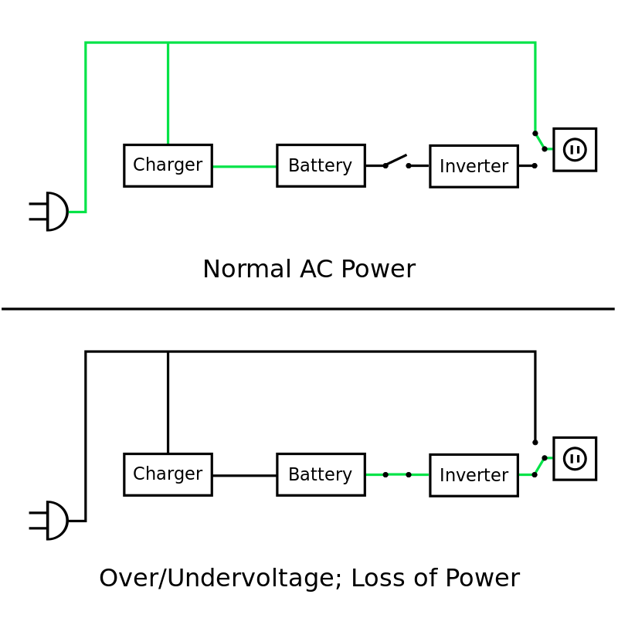

*Figure 2.1: Offline/standby AEPS: The green line illustrates the flow of electric power.*

### 2.2.2.2 Line Interactive

The line-interactive Emergency Power Supply is similar in operation to a standby AEPS, but with the addition of a multi-tap variable-voltage [autotransformer](https://en.wikipedia.org/wiki/Autotransformer). This is a special type of [transformer](https://en.wikipedia.org/wiki/Transformer) that can add or subtract powered coils of wire, thereby increasing or decreasing the magnetic field and the output voltage of the transformer. This may also be performed by a [*buck–boost transformer*](https://en.wikipedia.org/wiki/Buck%E2%80%93boost_transformer) which is distinct from an autotransformer, since the former may be wired to provide [galvanic isolation](https://en.wikipedia.org/wiki/Galvanic_isolation)(Solter, 2019)(Ton,2019).

This type of emergency power supply system is able to tolerate continuous under voltage [brownouts](https://en.wikipedia.org/wiki/Brownout_(electricity)) and overvoltage surges without consuming the limited reserve battery power. It instead compensates by automatically selecting different power taps on the autotransformer. Depending on the design, changing the autotransformer tap can cause a very brief output power disruption,[[6]](https://en.wikipedia.org/wiki/Uninterruptible_power_supply#cite_note-6) which may cause automatic power supply using backup battery equipped with a power-loss alarm to "chirp" for a moment.

This has become popular even in the cheapest automatic emergency power supply using backup battery because it takes advantage of components already included. The main 50/60 Hz transformer used to convert between line voltage and battery voltage needs to provide two slightly different turns ratios: One to convert the battery output voltage (typically a multiple of 12 V) to line voltage, and a second one to convert the line voltage to a slightly higher battery charging voltage (such as a multiple of 14 V). The difference between the two voltages is because charging a battery requires a delta voltage (up to 13–14 V for charging a 12 V battery). Furthermore, it is easier to do the switching on the line-voltage side of the transformer because of the lower currents on that side (Solter, 2019).

## 2.3 Rechargeable Batteries

Batteries are used to store energy for use when needed by converting chemical energy into electrical energy. A simple battery is comprised of multiple cells attached in series. A cell is made up of three part: two electrodes (an anode and cathode) in a chemical called an electrolyte. A rechargeable battery is capable of reversing the chemical reaction by forcing a current in the opposite direction, i.e the electron potential can be reversedby applying an external

voltage onto the battery, resulting in a reversal of the galvanic discharge that took place

initially.

## 2.4 Power Inverters

There are 3 major types of inverters - sine wave (sometimes referred to as a "true" or "pure" sine wave), modified sine wave (actually a modified square wave), and square wave.

### 2.4.1 Sine Wave

A sine wave is what you get from your local utility company and (usually) from a generator.  This is because it is generated by rotating AC machinery and sine waves are a natural product of rotating AC machinery. The major advantage of a sine wave inverter is that all of the equipment which is sold on the market is designed for a sine wave. This guarantees that the equipment will work to its full specifications. Some appliances, such as motors and microwave ovens will only produce full output with sine wave power. A few appliances, such as bread makers, light dimmers, and some battery chargers require a sine wave to work at all

### 2.4.2 Modified Sine Wave

A modified sine wave inverter actually has a waveform more like a square wave, but with an extra step or so. A modified sine wave inverter will work fine with most equipment, although the efficiency or power will be reduced with some. Motors, such as refrigerator motor, pumps, fans etc will use more power from the inverter due to lower efficiency. Most motors will use about 20% more power. This is because a fair percentage of a modified sine wave is higher frequencies - that is, not 60 Hz - so the motors cannot use it. Some fluorescent lights will not operate quite as bright, and some may buzz or make annoying humming noises. Appliances with electronic timers and/or digital clocks will often not operate correctly. Many appliances get their timing from the line power - basically, they take the 60 Hz (cycles per second) and divide it down to 1 per second or whatever is needed.  Because the modified sine wave is noisier and rougher than a pure sine wave, clocks and timers may run faster or not work at all. They also have some parts of the wave that are not 60 Hz, which can make clocks run fast. Items such as bread makers and light dimmers may not work at all - in many cases appliances that use electronic temperature controls will not control. The most common is on such things as variable speed drills will only have two speeds - on and off.

### 2.4.3 Square Wave

There are very few, but the cheapest inverters are square wave. A square wave inverter will run simple things like tools with universal motors without a problem, but not much else. Square wave inverters are seldom seen anymore.

## 2.5 Battery Charger

Charging a lead acid battery is a matter of replenishing the depleted supply of energy that the battery had lost during use. This replenishing process can be accomplished with several different charger implementations: “constant voltage charger”, “constant current charger” or a ““multistage" constant voltage/current charger”. Each of these approaches has its advantages and disadvantages that need to be compared and weighed to see which one would be the most practical and realistic to fit with our requirements.

### 2.5.1 Constant Voltage charging

Constant voltage charging is one of the most common charging methods for lead acid batteries. The idea behind this approach is to keep a constant voltage across the terminals of the battery at all times. Initially, a large current will be drawn from the voltage source, but as the battery charges and increases its internal voltage, the current will slowly fold and decays exponentially. When the battery is brought up to a potential full charge, which is usually considered around 13.8V, the charging voltage is dropped down to a lower value that will provide a trickle charge to maintain the battery as long as it is plugged into the charger. The best characteristic of this method is that it provides a way to return a large bulk of the charge into the battery very fast. The drawback, of course, is that to complete a full charge would take a much longer time since the current is exponentially decreased as the battery charges.

### 2.5.2 Constant Current Source

Constant current charging is another simple yet effective method for charging lead acid batteries. A current source is used to drive a uniform current through the battery in a direction opposite of discharge. This can be analogous to pouring water into a bucket with a constant water flow, no matter how full the bucket is. Constant current sources are not very hard to implement; therefore, the final solution would require a very simple design. There is a major drawback to this approach. Since the battery is always being pushed at a constant rate, when it is close to being fully charged, the charger would force extra current into the battery, causing overcharge. The ability to harness this current is the key to a successful charger. By monitoring the voltage on the battery, the charge level can be determined, and at a certain point, the current source would need to be folded back to only maintain a trickle charge and prevent overcharging. (Bharath, 2008)

# CHAPTER THREE

# DESIGN AND CONSTRUCTION

This chapter describes the experimental procedure or design, it also contains how the construction of the project is made.

## 3.1 System Description

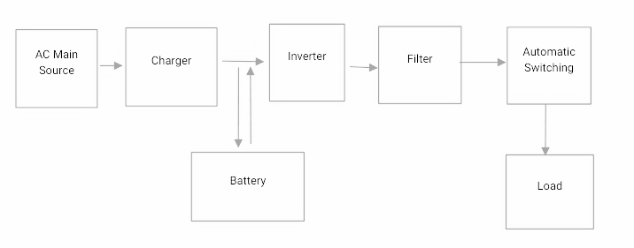The block diagram of the system, is given in figure.1. It consists of five (5) blocks interconnected to form the uninterruptible power supply system. The first block is the mains power supply in this case, it is a 220V from Mains which is bypassed o the load and used to charge the battery. The second stage is the storage battery for storing energy. The third stage is the inverter which converts 12V dc to 220V ac whenever mains fails. The fourth section is the filter which removes unwanted frequencies rom the inverters output. The fifth section is the load that requires uninterruptible power for continues operation. The block diagram of the device is as shown in figure 1.



*Figure 3.1: System block diagram*

**3.2. System Design**

This section of the report provides detailed calculations of the components used in the project

### 3.2.1 The Charging circuit

Since the output of the transformer is alternating, it is necessary to convert it to a direct or steady voltage before being used to charge electrical equipment.

Battery chargers have an input supply from the mains. A transformer is used to transform the voltage to the right voltage while on inverter section, and charging the battery while on mains supply.

A rectifier to convert the alternating input current into full-wave direct current and battery over-charge prevention circuit, ceases charging current from getting through to the battery when fully charge. Battery over-charge causes undesirable side reactions, in particular, decomposition of electrolyte. The latter leads to gas production and in turn leads to increase battery internal impedance. An over charging prevention circuit was incorporated to this design. More so, for efficiency and durability of the battery, low voltage status circuit detector is also incorporated with the project to prevent the battery from being drained excessively.

This over charge protecting circuit cuts off the supply to the battery if a specific voltage level is reached while the low level detector automatically short down the inverting unit of the system when the battery is drain beyond the preset voltage. The first stage is to convert the AC into unidirectional pulses and then these pulses pass through a filter where upon direct current at steady voltage is supplied to the load. The process of converting the AC to unidirectional pulses is known as rectification and filtering after rectification is called smoothing.

In this project, full wave rectification is used. Below is the diagram of a regulated power unit used for charging the battery. It consists of transformer, a bridge rectifier and a filter. The values are calculated as:

## 3.2.2 Mathematical Analysis

Power rating of the inverter is equal to 1000VA=1KVA Thus

P = IV.  …(3.1)

Since voltage source

= 12V

1000 = 1 × 12

I = $\frac{1000}{12}$

= 83A

But normally there should be allowance for energy wastage as a result of heat and

Voltage drop due to internal resistance of the battery.Thus using 67A for flexibility.

The total voltage that the switch can handle conveniently is giving by:

Vt = 2√2 × 12

= 9.79V

**The Rectifier**:

A bridge rectifier made from four diodes all 1N4007 is chosen, data sheet says it has a forward voltage drop of 1.0V at 3A

**Needed transformer voltage**

The needed transformer voltage is determined thus:

Vrms × 1.414 must be > 17 + 1.0 + (Vripple = 4V) = 22.0. …(3.2)

Vrms = $\frac{22.0}{1.413}$

= 15.56V

**Ccapacitor Sizing**

To determine the capacitor size

Vpk-pk ripple= $\frac{I Load }{fC}$ or C = $\frac{I Load }{f x Vpk-pk ripple}$…(3.3)

C = $\frac{2}{100 x 4}$

= $\frac{2}{400}$

= 0.005

= 5000 µF

with a minimum voltage rating of

36 × sqrt (2)

= 22V + 20% safety margin = 26.4V



*Figure 2: The charging Circuit*

### 3.2.2 The Inverter circuit

The heart of the emergency power supply is the inverter. An inverter is an electrical device that converts direct current (DC) to alternating current (AC) (Moise and others, 2000). The process of converting dc into ac is known as Inversion (the reverse of rectification). Thus an inverter is a device or circuit that changes dc power into ac power or in other words an inverter is an inverted converter, (Owen, 1996). The inverter incorporates an astable multivibrator which generates a square wave (the a.c. voltage) at a required frequency, a frequency reduction circuit, a Darlington pair to match the signal to a power transistor which in turn determines the power rating of the system. There is also a voltage regulator to regulate the d.c. voltage supplied to the various components and also serve as a link between the battery and the components, and a transformer to step up the output voltage to required levels.

### 3.2.3 The Automatic Control Circuit

The control circuit is comprised mainly of a relay, which is an electromagnetic device which can often be activated by little energy, causing a movable ferromagnetic armature to open or close one or several pairs of electrical contact points located in another control circuit or in a main circuit handling large energy. When a current is applied to the relay coil, the iron arm is attracted to the pole face of the contactor coil, and when the current is interrupted the arm is returned to its normal position by the spring. The arm can then be used to close or open a set of contacts. In this project the control circuit is connected such that when mains supply is available the arm is positioned so as to connect the load to the mains directly, and when mains supply is interrupted the arm is positioned so that the inverter output is connected to the load, through the transformer. Only one supply at a time – mains or inverter – is connected to the load at any one time.

## 3.3 Construction

The construction was first done on a breadboard as temporary, after which it was transferred to a veroboard. The veroboard was inspected of wrong linkages in its line which may be a mistake from the producers.The holes of the board were checked to be through forpassing the terminals of the components for soldering. An abrasive paper was used on the soldering sectionof the board for easy binding of the terminals on theboard

### 3.3.1 Component list

**Table. List of components.**

|  |  |  |
| --- | --- | --- |
| S/N | Item | Quantity |
| 1 | Battery 12V | 1 |
| 2 | Transformer | 2 |
| 3 | Transistors | 2 |
| 4 | Heat stick | 2 |
| 5 | Capacitor | 5 |
| 6 | Zener Diode | 1 |
| 7 | Diode | 8 |
| 8 | Fuse | 1 |
| 9 | Light Emitting diode | 2 |
| 10 | Volt meter | 2 |

### 3.3.2 Components layout

Components are usually placed on the plain side of the board, with their leads protruding through the holes. The leads are then soldered to the copper tracks on the other side of the board to make the desired connections, and any excess wire is cut off, the continuous tracks is neatly cut as desired to avoid continuity between conductors using a hand cutter made for the purpose or a knife. Tracks may be linked up on either side of the board using wire. With practice, very neat and reliable assemblies can be created, though such a method is labour-intensive and therefore unsuitable for production. Veroboard is also called stripboard. It is a widely-used type of electronic prototyping board characterized by a 0.1 inch (2.54 mm) regular (rectangular) grid of holes, with wide parallel strips of copper cladding running in one direction all the way across one side of the board. In using the board, breaks are made in the tracks, usually around 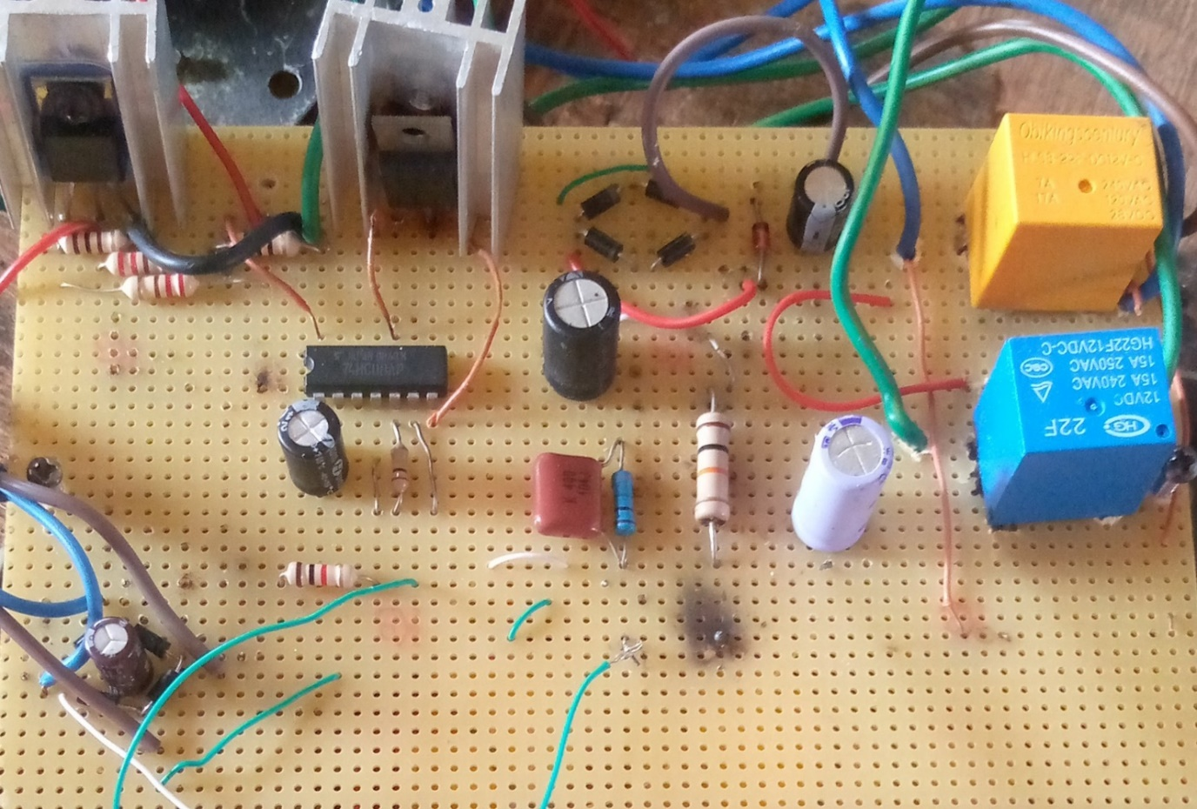holes, to divide the strips into multiple electrical nodes

*Figure 3.2: components layout*

### **3.3.3** Soldering

Solder is a metal alloy usually made of tin and lead which is melted using a hot iron. The iron is heated to temperatures above 600 degrees Fahrenheit which then cools to create a strong electrical bond. Solder is melted by using heat from an iron connected to a temperature controller. It is heated up to temperatures beyond its melting point at around 600 degrees Fahrenheit which then causes it to melt, which then cools creating the soldered joint, as well as creating strong electrical joints solder can also be removed using a de-soldering tool. A solder is a metal alloy used to create strong permanent bonds; such as copper joining in circuit boards and copper pipe joints. It can also be supplied in two different types and diameters, lead and lead free and also can be between .032” and .062”. Inside the solder core is the flux, a material used to strengthen and improve its mechanical properties.

The type of soldering employed is Soft soldering (90 °C - 450 °C) - This process has the lowest filler metal melting point of all the soldering types at less than around 400°C these filler metals are usually alloys, often containing lead with liquids temperatures under 350°C. Because of the low temperatures used in soft soldering it thermally stresses components the least but does not make strong joints and is then therefore unsuitable for mechanical load-bearing applications. It is also not suited for high temperature use as this type of solder loses strength and melts.

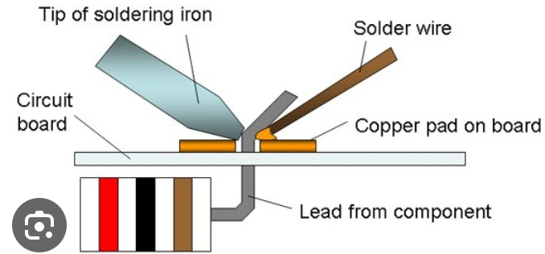

*Figure 3.4: The Components soldering*

### 3.3.4 Prototype Casing/Packaging

The completed project was cased inside a metal casing with dimensions as given in figure

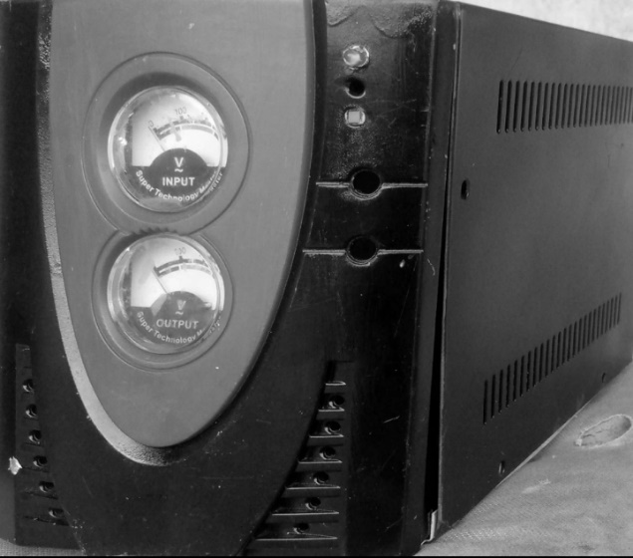

*Figure 3.5: Prototype casing*

## 3.4 Principles of Operation

The IC CD4047 connected in astable mode generates 200Hz of oscillations which is scaled down by the dual flip flops to 50Hz to drive the darlingtom pair transistors which serve to boost input impedance of the output 2N3055 power transistors. The power transistors alternately energize the two halve of the inverted transformer to give alternating induced current at the output equal to 220V at a frequency of 50Hz

## 3.5 Complete Circuit Diagram

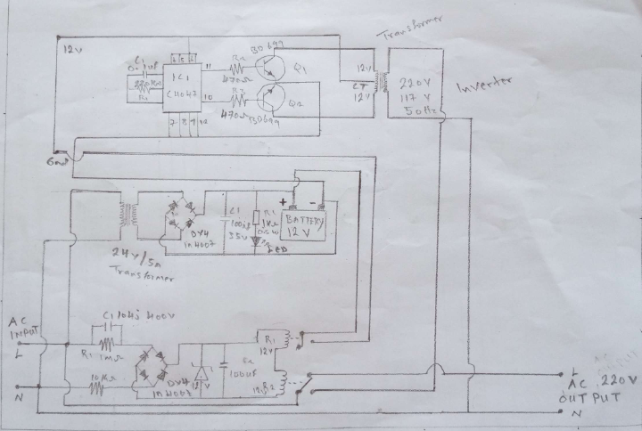The individual units put together form the complete system with schematic as shown in figure 3.6.

*Figure 3.6: The Complete Circuit Diagram*

# CHAPTER FOUR

# TESTING, RESULTS AND DISCUSSIONS

In this section, the prototype system is tested to determine the status of the components used and the operational status of the constructed project. It contains the findings (results) from testing of the constructed project. The results are presented in tables

## 4.1 Prototype Testing

In order to assess the performance of the AEPS, some measurements were taken for each of the four earlier named subunits. Two phases of tests were carried out, the first being on breadboard and the second after soldering on Vero board. The final testing was that on the entire system after having coupled the subunits together. Equipment used for the testing included digital multimeter (with frequency), d.c power supply, oscilloscope and analogue multimeter. The specific tests carried out included

1. continuity test
2. component status test
3. unit test
4. complete system test.

### 4.1.1 Input/Static Test

In continuity test, analogue meter set at resistance was used to check for short circuits and open circuits between conductors/wire and also to detect partial contacts. Some of the wave shapes displayed on the oscilloscope during the unit tests are presented in Figure 8. Using a 120Ah/12V d.c. car battery for the test, the inverter produced alternating voltage from the 12V d.c. source. The charger output was 15V D.C, 5A when loaded and tested. The contactor was also tested and found to be working very well. Digital multimeter was used to verify the theoretical/specified characteristic of each component.

### 4.1.2 Output or Battery Performance Test

In order to give information as regards the backup time available for the system the following measurements were taken: input (battery voltage with time) and output (inverter voltage with time).

The results obtained are as shown in Table 1. This uninterruptible power supply unit when compared to its model counterparts found in the market, goes for longer hours that can supplement and serve as a backup power to mains supply for a time period specified by the client.

The system is of great importance for all fields of life including military, hospital, airport,

telex system etc. Besides, it is also mostly needed in computer environment, where information storage is given priority.

## 4.2 Results

All readimgs and observations were reecorded accordingly.

### 4.2.1 Result

**Table 1: Input Test Result (Loaded and unloaded)**

|  |  |  |
| --- | --- | --- |
| Battery Status | Test Medium | Reading |
| No load | D.C Voltmeter | 13.5V |
| Loaded | D.C Voltmeter | 12.6V |

**Table 2:Output test result (Loaded and Unloaded)**

|  |  |  |
| --- | --- | --- |
| Inverter Status | Test medium | Readings |
| Unloaded | A.C voltmeter | 230V |
| Loaded | A.C Voltmeter | 219V |

**Table 3: Battery Performance and Test Results**

|  |  |  |
| --- | --- | --- |
| Time in Minutes | Battery D.C voltage (V) | Inverter output A.C voltage (V) |
| 0 | 12.41 | 250 |
| 15 | 12.40 | 246 |
| 30 | 12.39 | 244 |
| 45 | 12.37 | 240 |
| 60 | 12.35 | 238 |
| 75 | 12.24 | 236 |
| 90 | 12.15 | 235 |
| 105 | 12.12 | 228 |
| 120 | 12.08 | 223 |
| 135 | 12.01 | 218 |
| 150 | 11.97 | 215 |
| 165 | 11.94 | 214 |
| 180 | 11.88 | 212 |
| 195 | 11.84 | 208 |
| 210 | 11.80 | 200 |
| 225 | 10.90 | 186 |
| 240 | 10.84 | 170 |

## 4.3 Prototype Operation

The constructed AEPS is Line Interactive. The bidirectional converter/inverter connects the battery bank to the load. During normal mode of operation, the main AC line supplies the power to the load and the bidirectional converter/inverter charges the battery. During the grid failure, the static switch dis- connects the load from the main supply and the bidirectional converter/inverter supplies the power to the load.

# CHAPTER FIVE

# CONCLUSION AND RECOMMENDATION

This chapter presents the significance of the study and stresses the findings upon which a conclusion(s) is drawn in line with the objectives set, it acknowledges the limitations and suggests/ recommends further improvement / research which may be carried out on the topic.

## 5.1 Conclusion

AEPS is a device used for back-up power for critical and essential loads. The design of the AEPS from discrete components based on the principle that any system that can generate pulsating alternating waveform of any regular shape (sawtooth, ramp, square, sinusoidal) with appropriate mark to space ratio from a d.c source, can be used to generate pure or almost clean a.c. signals. The waveform generator was IC CD4047 configured in the astable mode. The square waveform produced was rounded to near sinusoidal waveform by transistor amplification and switching.

The aim of this project work, which was to design and construct a reliable AEPS system for lower power domestic use was achieved. When tested, the system functioned as anticipated according to design. It achieved very fast load transfer between mains power and battery power on mains failure, and again between back-up power and mains power or restoration of mains power.

## 5.2 Recommendations

In future work, it is planned to design and implement an intelligent AEPS. Implementation of this device in computer centers and hospitals will encourage energy efficiency, making electrical appliances last longer.

It is therefore recommended that:

1. The inverter section should be redesigned to give pure sine wave.
2. The design can be made to be powered by battery/mains to guarantee output.
3. Funds to be made available for perfection of viable projects undertaken by our graduating students.

# REFERENCES

Adewale, L. and Ogunleye, T. (2019). “A current and future state of art development of hybrid energy system using wind and PV-solar:AReview”,20 , <https://pdfs.semanticscholar.org/f6db/5efc703a5919e8e946a526e97630f057e6c6.pdf>

Barnet, Y. (2020) Configuration of a standalone hybrid wind-diesel photoelectric unit for guaranteed power supply for mineral resource industry facilities. *International Journal of Applied Engineering Research*, 1(11), 20, 233-238.

Bharath, P., Krishna, P., Jon P. and Christopherson, S. (2018), “Automotive Battery Management Systems”-IEEE AUTOTESTCON 2008Salt Lake City, UT, 8-11 September 2018

Hans, P., Sivaramakrishna, N., Reddych, and. Kasi, R. (2021). Modular Hybrid Power AEPSn Through Solar-Wind Power and Modified Solar Panel, ISSN:2231-5381, (2013), <http://www.ijettjournal.org>

Hans, P., Sivaramakrishna, N., Reddych, and. Kasi, R. (2021). Modular Hybrid Power UPSn Through Solar-Wind Power and Modified Solar Panel”, ISSN:2231-5381, (2013), <http://www.ijettjournal.org>

Kusko, T. (2019). Changing Trends in the Design of Uninterruptible Power Supply, IEE Journal Electronics and Power 33, (7PP): 457-460. July 1987.

Mauzer, E., Selen, A., Wellis, G.and David, K. (2020) Emergency/Standard Power Systems, Intenational Journal Of Innovative Research In Science,Engineering and Technology,ISSN(online);2319-8753,New York: Mc Grew-Hill

Musa, A. E and Chukwurah., (2020). A 24 Hours Uninterrupted Power Supply Unit (UPS) Conference on New Product and Technologies for SMEs, May 21 -23, 2001, Benin City, Nigeria.Owen, Edward L. (January/February 1996). "Origins of the Inverter". IEEE Industry

Omutola, L., Shegun, K., West, S. and Helen, J. (2021). Design and construction of a a 1KVA standalone (UPS) Uninterruptible Power Supply, United States Patent, Patent N0.: US 6,184,593

Solter, W. (2019), *"A new international UPS classification by IEC 62040-3", 24th Annual*  *International Telecommunications Energy Conference, pp. 541–545,*[*doi*](https://en.wikipedia.org/wiki/Doi_(identifier))*:*[*10.1109/INTLEC.2002.1048709*](https://doi.org/10.1109%2FINTLEC.2002.1048709)*,*[*ISBN*](https://en.wikipedia.org/wiki/ISBN_(identifier))[*0-7803-7512-2*](https://en.wikipedia.org/wiki/Special:BookSources/0-7803-7512-2)*,*[*S2CID*](https://en.wikipedia.org/wiki/S2CID_(identifier))[*195862090*](https://api.semanticscholar.org/CorpusID:195862090) 17

Sufia, Z. (2020). Integration of Renewable Energy Resources in Microgrid. Energy and Power Engineering, 7, (2015) ,12-29. <http://dx.doi.org/10.4236/epe.2015.71002>

Sulo, L., Guro, F. (2020). “Modelling of solar/diesel/battery hybrid standalone power systems for far North Cameroon”, 832-844, 20. doi:10.1016/j.renene. 202.03.010

Thilagavathy R, Spoorthi Y, Nalina H. (2019) “Automatic Power Supply Controller By Four Different Sources” ,2nd International Conference on “Innovative Trends in Science,Engineering and Management”,(2016),SBN:978-93- 86171-10-8, ICITSEM-16, http:/conferenceworld.in

Ton, M. (2019. Fortenbery, Brian; Tschudi, William (January 2007). "DC Power for Improved Data Center Efficiency" (PDF). Lawrence Berkeley National Laboratory. Archived from [the original](http://hightech.lbl.gov/documents/DATA_CENTERS/DCDemoFinalReport.pdf) (PDF) on 2010-10-08.